|  |
| --- |
| Assignment: To create a concept online shopping store |

|  |
| --- |
| **Requirement Specification**:   1. To create an online shopping store 2. Create a PPT 3. Crate a report on mobile ecommerce and threats |

|  |
| --- |
| **Application and Implementation**:  The concept shopping site has developed in wordpress and woocommerce |

**Screenshots:**

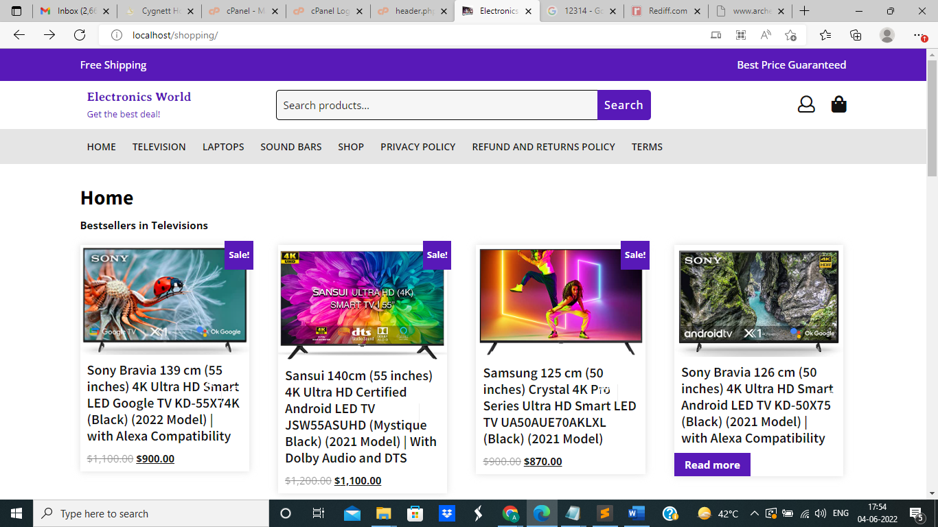

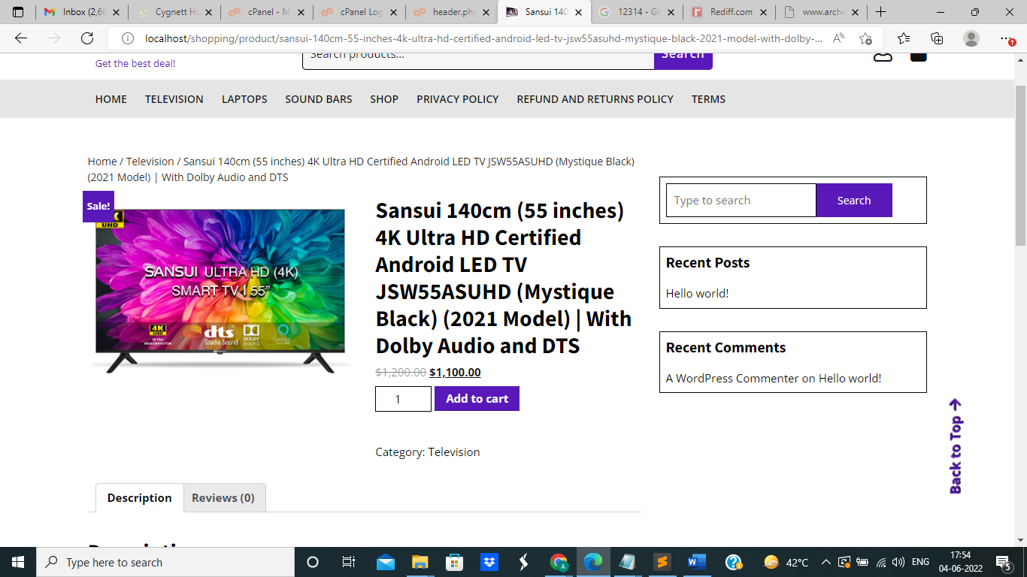

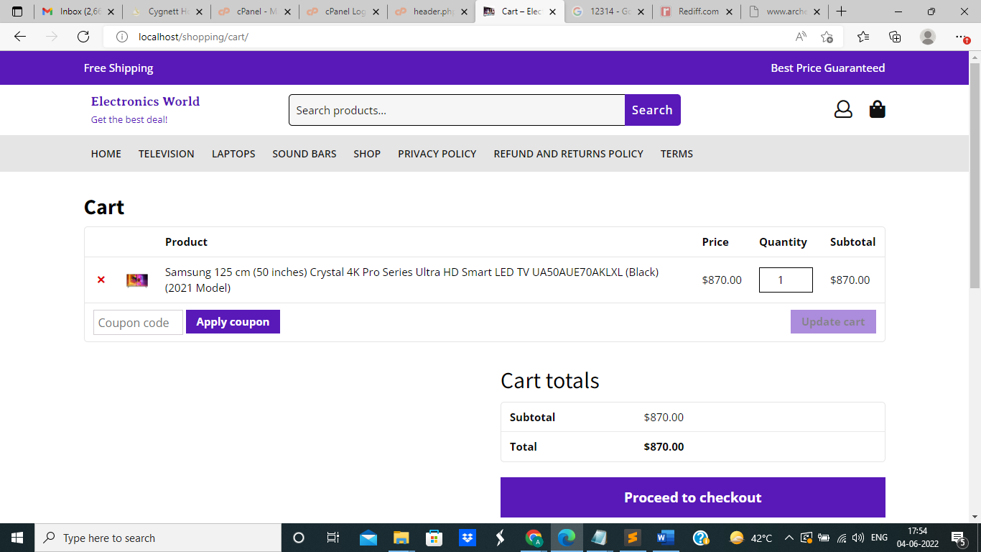

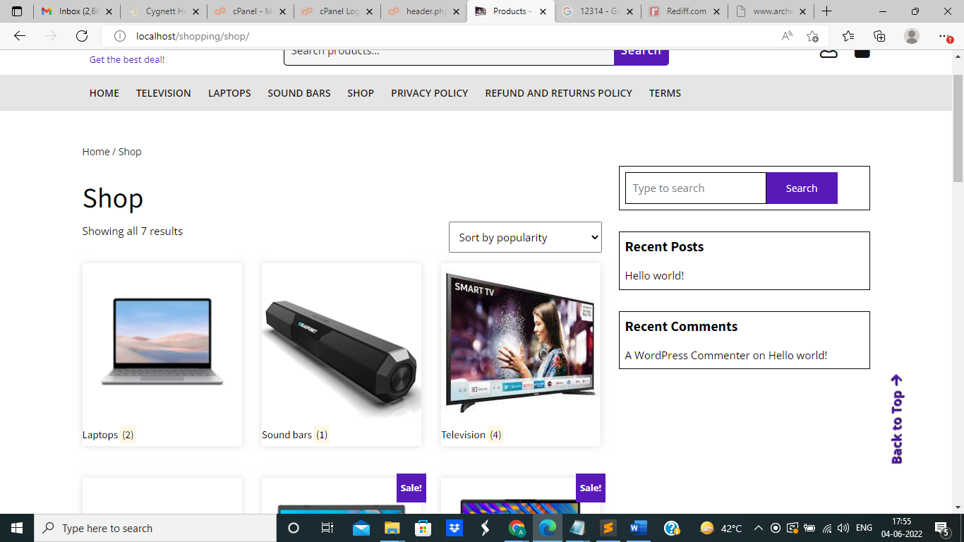

**Notes:**

* [**http://localhost/shopping/**](http://localhost/shopping/) **is the path of the project**
* **The project is in WordPress/WooCOmmerce**
* **Shopping folder contains the wordpress files**
* **shop_db.sql is the sql file for this project**
* [**http://localhost/shopping/wp-login.php**](http://localhost/shopping/wp-login.php) **is the admin login**
* **Admin user – admin**
* **Admin password - TFpjXOxWvyE89cWa)g**
* **Since the project was done in localhost, payment integration couldn’t be done. For that a SSL connection is needed. In admin panel of wordpress, under woocommerce section, options to configure desired payment gateways are available.**
* **Products, product categories, information etc can be updated via the admin.**